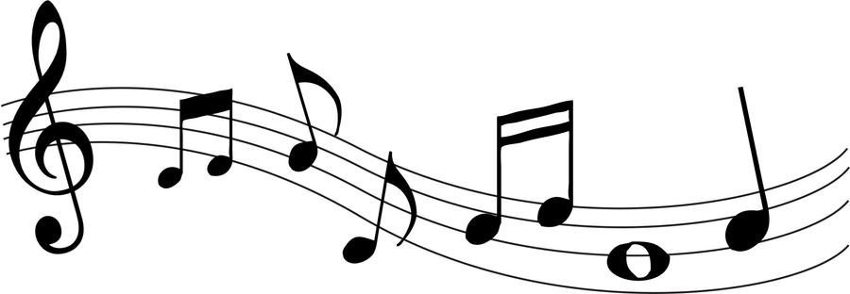
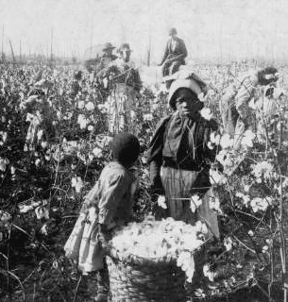

FREEDOM

MUSIC, A TIMELESS PRECIOUS GIFT
Music has been a timeless gift that has artfully channeled our inner spirit. It continues to trifle our emotions, thus influencing our behavior, connectivity with others. From nature’s first sound of music, to the composition of melodic a capellasongs and the evolution of musical instruments, music has transcended throughout the ages of time. Music has inspired and yet the art of gloom with the saddest blues make you retire hope, gladness and joy. Music tell the tales of economic woes; music depicts the stories of many lost souls. Music paints pictures; it develops a variety of moods-satiating the hungriest appetites. Music guides-it takes you to a place of relaxation; freedom. The independence to escape from harsh realities, the given right to indulge and rest in rhythm. And so, the songs of the cotton fields and the songs of the Underground Railroad were sweet music. Were these songs sang to pass time in the cotton fields? Or were they songs with hidden messages promising a hope towards freedom?
Songs as an Expression
Songs were used in everyday life by black slaves. Singing was a tradition brought from Africa by the first slaves; sometimes their songs are called spirituals. There are an estimated over 5,000 spirituals, usually composed spontaneously by different slaves. They were expressions of the great pains and sorrows but they also had hope within them unlike blues which were only about the troubles.Singing served many purposes such as providing repetitive rhythm for repetitive manual work, inspiration and motivation. Singing was also use to express their values and solidarity with each other and during celebrations.
Songs and the Bible
Many slaves adopted Christianity when they were brought to America. Songs used Biblical references and analogies of Biblical people, places and stories, comparing them to their own history of slavery. They were able to relate stories such as Daniel and the Lion Din; Israelites and bondage in Egypt; Shadrach, Meshach, and Abenego (Three Hebrew boys) forced in a fiery furnace to slavery.These stories gave them hope that one day they would be saved and set free like Daniel, the Israelites, and the three Hebrew boys.Slaves sang spirituals to not only talk about their sorrows but to give them hope that one day things will be better.Listed below are several famous spiritual songs; examine the lyrics of these songs to discover the biblical messages:
Oh go down, Moses,
Way down into Egypt’s land,
Tell old Pharoah,
Let my people go.

Oh Pharaoh said he would go cross,
Let my people go,
And don’t get lost in the wilderness,
Let my people go.
You may hinder me here, but you can’t up there,
Let my people go,
He sits in the Heaven and answers prayer,
Let my people go!

Biblical Message: This song informed the slaves that it was unsafe to escape; danger was near. Just think of the many lives that were saved with this song as a warning.

Hail, oh hail, ye happy spirits,
Death no more shall make you fear,
Grief nor sorrow, pain nor anguish,
Shall no more distress you there.

Around Him are then thousand angels,
Always ready to obey command;
They are always hovering round you,
Till you reach the heavenly land.

Jesus, Jesus will go with you,
He will lead, you to his throne;
He who died, has gone before you,
Through the wine-press all alone.

He whose thunders shake creation,
He who bids the planets roll;
He who rides upon the tempest,
And whose scepter sways the whole.

Biblical message: This song was sung during Underground Railroad when Harriet Tubman returned from taking a detour to get food for the day. This song let the slaves know it was safe to approach her. It was a song of hope and inspiration; the slaves didn’t have to grieve or suffer pain or anguish. Just as the angels encamp around the saints keeping them safe, those same angels were there for them. The song references Harriet Tubman as Jesus, the one that will lead the slaves to his throne (freedom).

Chorus: Wade in the Water, wade in the water children,
Wade in the Water, God’s gonna trouble the water.
Who are those children all dressed in Red?
God’s gonna trouble the water.
Must be the ones that Moses led.
God’s gonna trouble the water.

Chorus: Who are those children all dressed in White?
God’s gonna trouble the water.
Must be the ones of the Israelites.
God’s gonna trouble the water.

Chorus: Who are those children all dressed in Blue?
God’s gonna trouble the water.
Must be the ones that made it through.
God’s gonna trouble the water.

Biblical message: Harriet Tubman used “Wade in the Water” to tell slaves to get into the water to avoid being seen and make it through. This is an example of a map song, where directions are coded into the lyrics.
Songs Referencing the Map Towards Freedom
Slaves were able to use the spirituals as “coded messages” to communicate and relay messages throughout their communities. Black slaves were able to use spirituals to outsmart their masters. The masters enjoyed the music of the slaves but didn’t pay close attention to the actual words that they were singing. Many times the spirituals would contain phrases that were about escaping to freedom.
The most famous song wasFollow the Drinking Gourd which usedthe metaphor of a drinking gourd to symbolize the constellation of stars known as the Big Dipper, containing the North Star, an important compass guide for individuals and families who needed to be certain that they were continuing to travel in the direction of north as they made their way to freedom. The drinking gourd refers to the hollowed out gourd used by slaves (and other rural Americans) as a water dipper. But here it is used as a code name for the Big Dipper star formation, which points to Polaris, the Pole Star, and North.These directions then enabled fleeing slaves to make their way north from Mobile, Alabama to the Ohio River and “north” toward Canada. Canada did not have laws condoning slavery. Canada, was the beacon of hope for the slaves; Canada was freedom.
FOLLOW THE DRINKING GOURD
LYRICS | EXPLANATION
VERSE 1 | Taken together, this verse suggests escaping in the spring and heading North to freedom.
When the sun come back, | Refers to the winter or spring. The days are getting longer, and the angle of the sun is higher each day at noon.
When the firs' quail call, | Refers to the breeding season. Quail in Alabama start calling to each other in early to mid-April.
Then the time is come
Foller the drinkin' gou'd. | The "drinkin' gou'd" alludes to the hollowed out gourd used by slaves (and other rural Americans) as a water dipper. Used here it is a code name for the Big Dipper star formation, which points to Polaris, the Pole Star, and North.
CHORUS
Foller the drinkin' gou'd,
Foller the drinkin' gou'd;
For the ole man say, | "Ole man" is nautical slang for "Captain" (or "Commanding Officer.") According to Parks, the Underground Railroad operative Peg Leg Joe was formerly a sailor.
"Foller the drinkin' gou'd."
VERSE 2 | Describes how to follow the route, from Mobile, Alabama north.
The riva's bank am a very good road, | The first river in the song is the Tombigbee, which empties into Mobile Bay. Its headwaters extend into northeastern Mississippi.
The dead trees show the way, | According to Parks, Peg Leg Joe marked trees and other landmarks "with charcoal or mud of the outline of a human left foot and a round spot in place of the right foot." (1)
Lef' foot, peg foot goin' on,
Foller the drinkin' gou'd.
CHORUS
VERSE 3 | Describes the route through northeastern Mississippi and into Tennessee.
The riva ends a-tween two hills, | The headwaters of the Tombigbee River end near Woodall Mountain, the high point in Mississippi and an ideal reference point for a map song. The "two hills" could mean Woodall Mountain and a neighboring lower hill. But the mountain itself evidently has a twin cone profile and so could represent both hills at once.
Foller the drinkin' gou'd;
'Nutherriva on the other side | The river on the other side of the hills is the Tennessee, which extends outward in an arc above Woodall Mountain. The left-hand side proceeds virtually due north to the Ohio river border with Illinois – definitely the preferred route, since the right hand side meanders back into northern Alabama and then proceeds up into Tennessee.
Follers the drinkin' gou'd.
CHORUS
VERSE 4 | Describes the end of the route, in Paducah, Kentucky.
Wha the little riva | When the Tennessee...
Meet the grea' big un, | ...meets the Ohio River. The Tennessee and Ohio rivers come together in Paducah, KY, opposite southern Illinois.
The ole man waits-- | Per one of Parks's informants, the runaways would be met on the banks of the Ohio by the old sailor. Of course, the chances that Peg Leg Joe himself would be there to meet every escapee (as depicted literally in the children's books) are quite small.
Foller the drinkin' gou'd.
1.

The beautiful music of the spirituals promoted inspiration and encouragement despite the atrocities and harsh conditions of slavery. The spirituals served two-fold purpose: While most slaves sang spirituals to pass time with the long rigorous hours in the cotton fields, it oftentimes served as communicative warning messages for other slaves attempting to escape slavery. The spirituals are timeless melodies passed throughout many generations. They are lasting prints forever woven into the world where hope, resilience, and persistence prevail.

References
- Bresler, Joel. Follow the Drinking Gourd: A Cultural History. What The Lyrics Mean.http://www.followthedrinkinggourd.org/What_The_Lyrics_Mean.htm

